PRACTICAL - 8

1. Give 10% interest to all depositors.

Output:

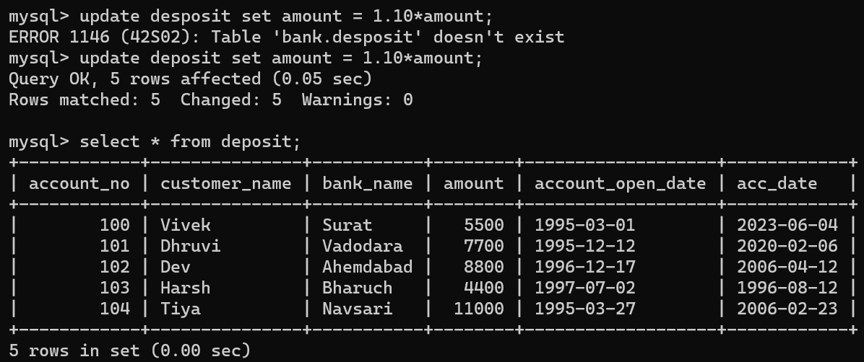

1. Give 10% interest to all depositors having bank name surat

Output:

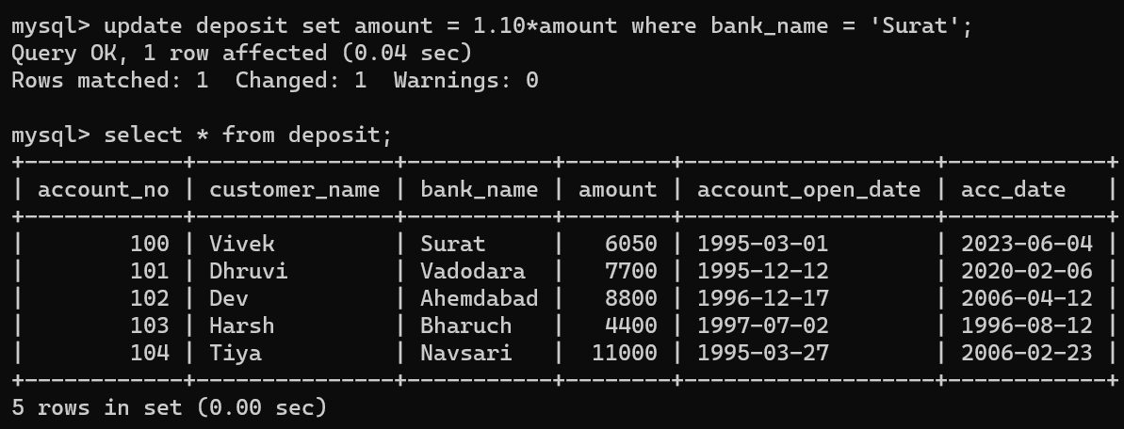

1. Give 10% interest to all depositors living in nagpur and having branch city bombay.

Output:

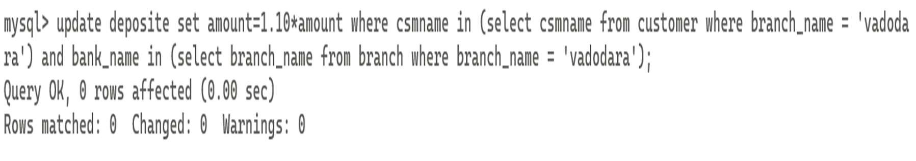

1. Write a query which changes the department number of all employees with emp  
   _no 7788’s job to employee 7844’current department number.

/* Question does not convey proper meaning. So, new question is: Write a query which changes the department number of all employees with employee

7844’current department number. */

Output:

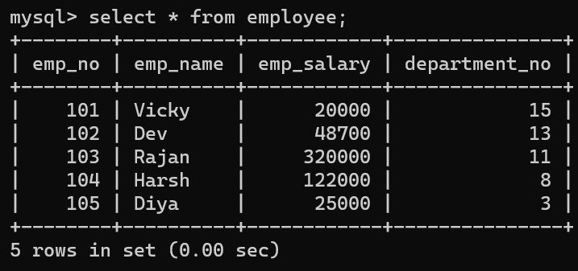

1. Transfer 10 Rs from account of anil to sunil if both are having same branch.

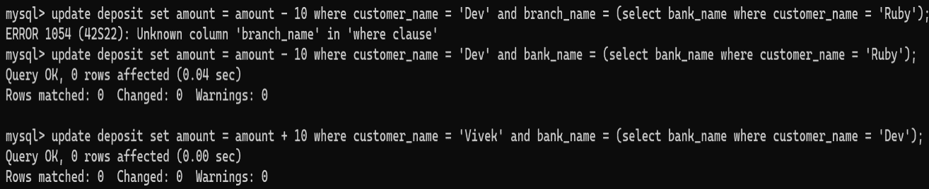

1. Give 100 Rs more to all depositors if they are maximum depositors in their respective branch.

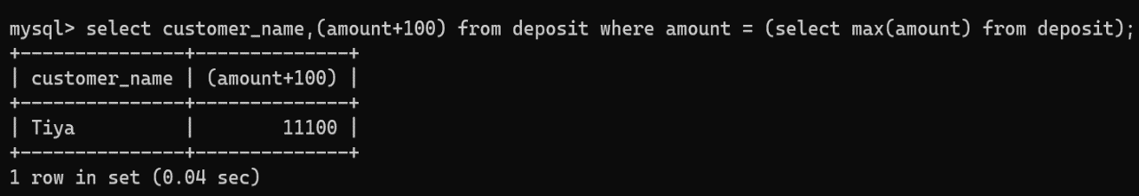

1. Delete deposit of Vivek.

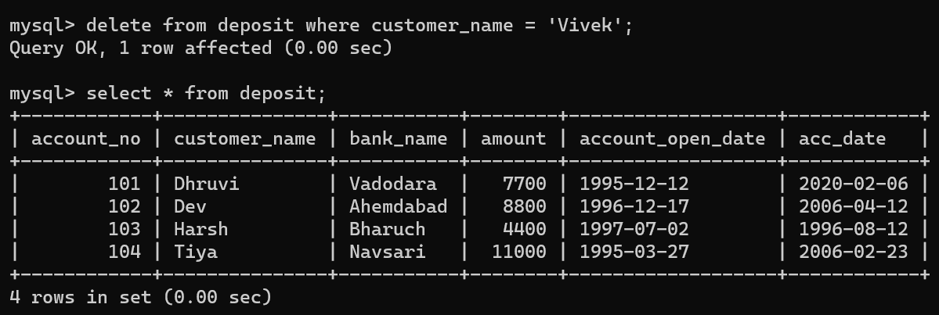

1. Delete borrower of branches having average loan less than 1000.

